Experiment 3

Anova Analysis

**Name:** Aryan Dali **UID:** 2019120016

**Class:** TE EXTC **Subject:** Data Analytics

The dataset used is the Heart dataset which is inbuild in the SAS software. It has the patient’s living status, heart rate, cholesterol level, age, sex and smoking levels.

After seeing the data set three Hypothesis were made:

**Hypothesis 1**

Ho: If the cholesterol levels are high then the Weight of the person will be high.

Ha: If the cholesterol levels are high then the Weight of the person will not necessarily be high.

**Hypothesis 2**

Ho: If the person smokes, he will die early.

Ha: If the person smokes the person will not necessarily die early.

**Hypothesis 3**

Ho: Cholesterol levels depends on the sex of the person

Ha: Cholesterol levels does not depends on the sex of the person

**Code**

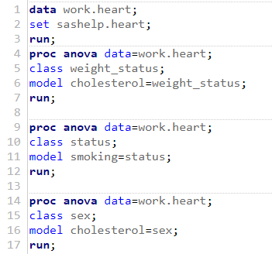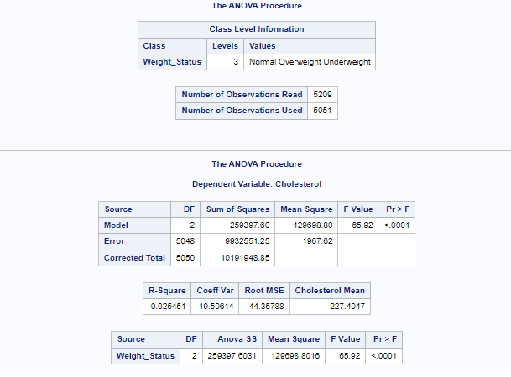

*Fig 1*

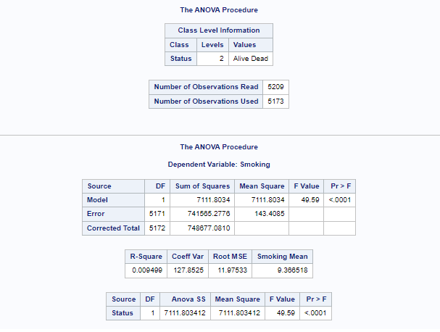

*Fig 2*

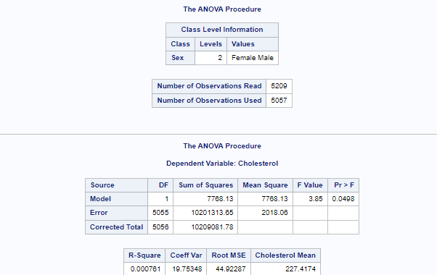

*Fig 3*

**Conclusion**

1. In Fig 1 for case 1 we can see that the p-value obtained is less than 0.001 therefore we accept the alternate hypothesis which is that, If the cholesterol levels are high then the Weight of the person will not necessarily be high.
2. In fig 2 for case 2 we can see that the p-value obtained is less than 0.001 therefore we accept the alternate hypothesis which is that, If the person smokes the person will not necessarily die early.
3. In fig 3 for case 3 we can see that the p-value obtained is less than 0.05 therefore we accept the null hypothesis which is that, Cholesterol levels depends on the sex of the person